Unveiling the Wilson Clash V3 Tennis Racket: Power Redefined

Discover the all-new Wilson Clash v3 Tennis Racket, designed to redefine power, comfort, and control for club players.

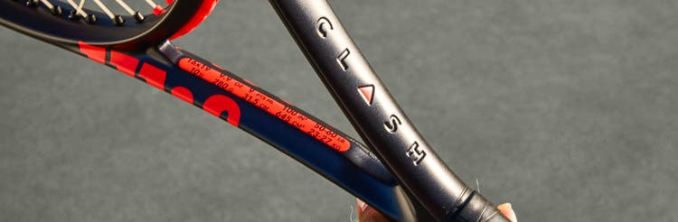

The Wilson Clash tennis racket line has redefined how players experience the game. Known for its performance-enhancing pairing of frame flexibility and stability, the Clash has become a favorite among club players looking to elevate their game. With the release of the **Clash v3 Tennis Racket**, Wilson has taken this groundbreaking line to the next level, offering enhanced features that cater to the needs of modern tennis players. If you're exploring the **best tennis rackets of 2025**, this new Wilson tennis racket deserves a spot at the top of your demo list.

Whether you're a 3.0 or 4.0 player competing in doubles, singles, or both, Clash v3 delivers a unique feel that empowers you to play above your level. Let’s dive into what makes Clash v3 the ultimate choice for club players seeking the **best tennis rackets for power, comfort and control.**

What Sets the Clash v3 Apart?

The Clash v3 racket line maintains the core characteristics that made its predecessors a hit but introduces cutting-edge advancements to elevate your game further. This updated version focuses on providing comfortable power, improved stability, and unmatched forgiveness, allowing you to hit with confidence and consistency.

Here are the standout features of the **Clash v3 Tennis Racket:**

1. Comfortably-Delivered Power

Wilson has perfected Clash’s patented layup to further redefine how a player experiences power. All-new SI3D technology allowed engineers to optimize the frame’s flexibility and stability to deliver power comfortably, making it an ideal choice for players who value a plush, in-control feel without sacrificing power. Learn more about SI3D technology in the video below.

2. Increased Off-Center Stability

Clash v3 has been engineered to enhance stability on off-center contact. Without altering the racket's weight or balance, “Hit Stabilizer” increases racket inertia at 3 & 9 to make Clash v3 the most forgiving Clash yet, helping players keep more balls in play thanks to a more consistent rebound.

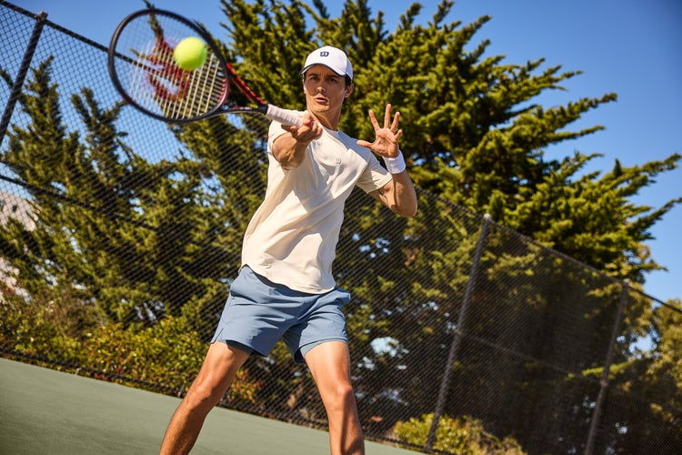

3. Refined Geometry for Softer Performance

Key bending areas have been smoothed and refined to add softness and forgiveness. This results in a racket that feels more responsive, giving players the confidence to execute precise shots even under pressure.

4. Easier-to-Replace Bumpers & Grommets

Wilson has added it’s hassle-free Click-and-Go bumper & grommet system, making it easier than ever to replace the bumper guard. This user-friendly addition ensures you can maintain your racket and string’s peak performance with minimal effort.

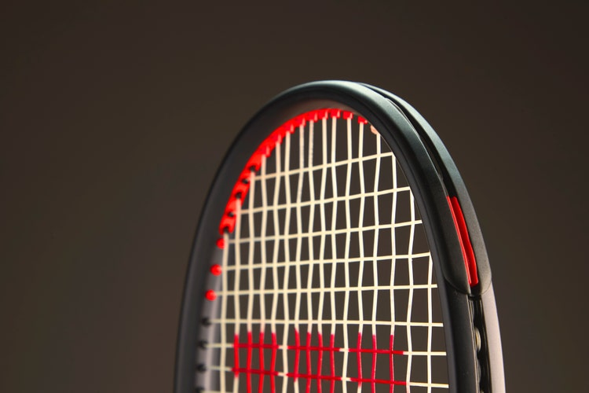

5. Matte Black Design

Clash v3’s sleek “graphite black” colorway not only looks stunning in the sun but also signals its high-performance capabilities. It’s a racket that performs as beautifully as it looks.

6. Improved Spec Tolerance

Clash v3 continues Wilson’s push to bring their quality control to the level of their innovation. First instituted with Blade v9, Wilson now measures every performance racket built at their factory on the Baiardo Tune Pro to ensure best-in-class weight and balance consistency frame to frame.

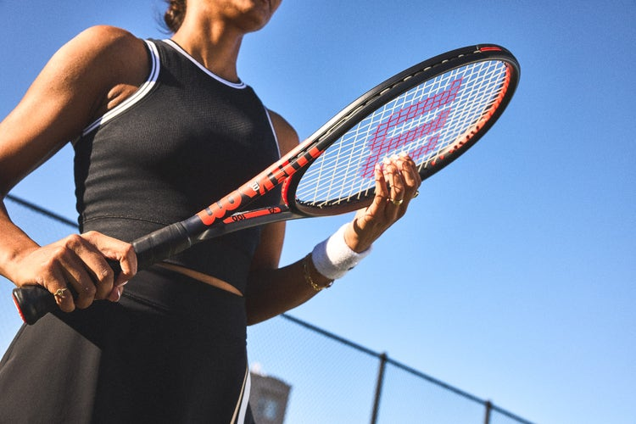

[EXPLORE CLASH V3](https://www.wilson.com/en-us/tennis/collections/clash-v3?)

Clash v3 Models

The Clash v3 Tennis Racket line offers a range of models tailored to various player types. Each model retains the unique Clash feel while catering to different skill levels and player needs.

1. [Clash 100 v3](https://www.wilson.com/en-us/product/clash-100-v3-0-frm-wr17280)

The most versatile option in the lineup, the Clash 100 v3 is perfect for club players looking to improve through increased power, comfort and control.

2. [Clash 100 Pro v3](https://www.wilson.com/en-us/product/clash-100-pro-v3-0-frm-wr17270)

The Pro model offers a slightly heavier frame, making it an excellent choice for players seeking added plow through and stability. Its 16x20 string pattern increases control for players with faster-than-average swing speeds.

3. [Clash 100L v3](https://www.wilson.com/en-us/product/clash-100l-v3-0-frm-wr17290)

This lighter version is ideal for players who prefer increased maneuverability and faster swings. The 100L v3 still delivers the signature Clash feel with added forgiveness.

4. [Clash 108 v3](https://www.wilson.com/en-us/product/clash-108-v3-0-frm-wr17310)

With its oversized head, the Clash 108 v3 offers unmatched forgiveness and a larger sweet spot, making it perfect for players who prioritize power and consistency. It’s extended length makes it easier to get to those hard-to-reach shots.

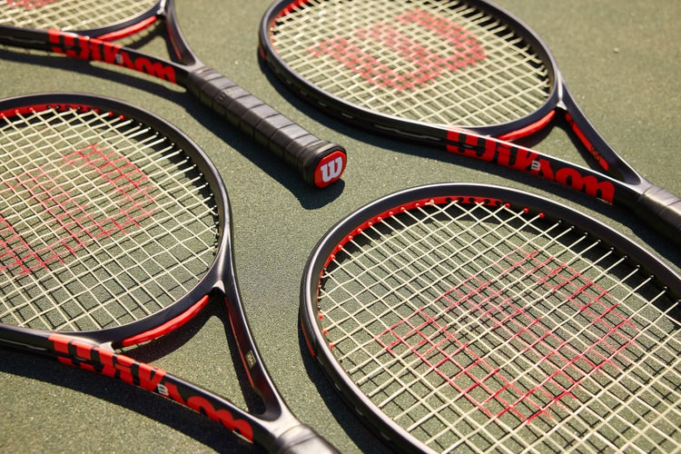

[SHOP CLASH V3](https://www.wilson.com/en-us/tennis/collections/clash-v3)

Comparing Clash v3 to Previous Models

The Clash v3 builds on the strong foundation of its predecessors, enhancing performance in key areas:

* **Flexibility and Stability:** Clash v3 is built off the flexibility and stability of the beloved v1 , but takes it up a notch by enhancing off-center stability for a more consistent rebound.
* **Forgiveness:** Increased frame inertia at 3 & 9 ensures even mishits feel solid and controlled.
* **Maneuverability:** The refined geometry of Clash v3 makes it quicker through the air than previous versions. The slightly-reduced weight of the Pro model also makes this option easier to maneuver.
* **Sustainability:** The addition of plant-based components makes Clash v3 a more environmentally friendly choice than other power-segmented rackets without sacrificing performance.

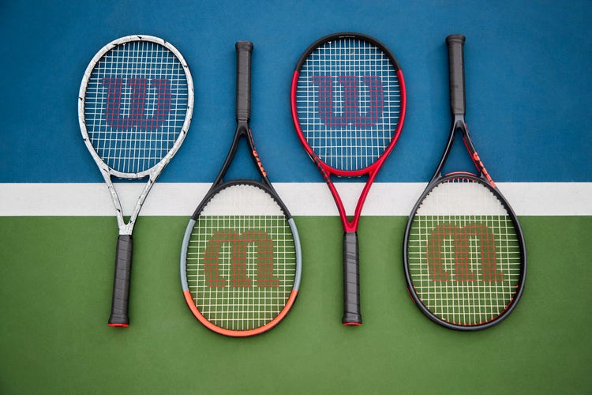

Who Should Use the Clash v3?

The Clash v3 is designed for club players, particularly those at the 3.0 to 4.0 level, who play a mix of singles and doubles. These players will appreciate the racket's ability to deliver enhanced power comfortably without sacrificing plush feel and control.

If you're looking for a racket that allows you to hit confidently, maintain control, and keep more balls in play, the Clash v3 is an excellent choice. It’s also one of the best tennis rackets for power and stability, making it a standout option for players aiming to elevate their game.



Why the Clash v3 is Among the Best Tennis Rackets of 2025

The Wilson Clash v3 is more than just a new Wilson tennis racket—it’s a game-changer for club players. Its comfortable power, enhanced forgiveness, and commitment to quality control make it one of the best tennis rackets of 2025. Whether you’re seeking flexible power, unmatched stability, or spec consistency frame to frame, the Clash v3 delivers it all.

With a range of models to suit different player types, the Clash v3 offers something for everyone. Don’t just take our word for it—try the Clash v3 Tennis Racket and experience the difference for yourself. Your best game is just a swing away.

Clash v3 Bag Line

The Wilson Clash v3 product line includes a line of performance bags with various styles designed for Clash player needs. Each bag is designed from the silhouette of the all-new Super Tour Collection, Wilson’s most premium racket bag line designed to meet the needs of players from Tour level to local leagues.

The Clash v3 Bag Line includes a 6-pack and 3-pack racket bags, as well as a backpack so you can take tennis to go.

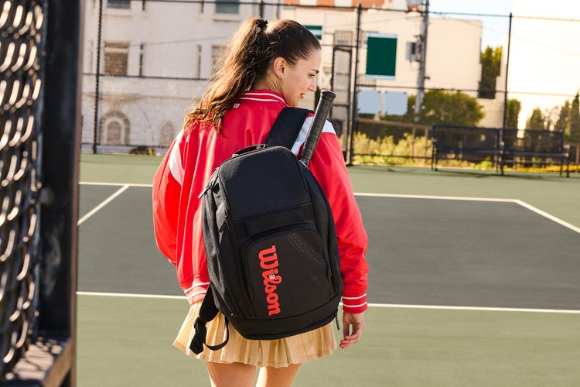

[EXPLORE CLASH V3](https://www.wilson.com/en-us/tennis/collections/clash-v3)